D1_Nihar_84066
ASSIGNMENT 7
1. D1_nihar_84066>select count(*)"NO OF ORDERS ON 3RD OCT" from ORDERS where month(odate)=10 and day(odate)=03;

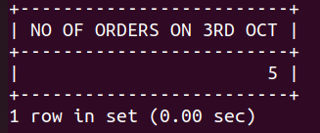

2. D1_nihar_84066>select count(*)"NO OF CITIES NOT NULL" from CUSTOMERS where city is not null;
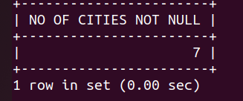

3. D1_nihar_84066>select distinct cnum, min(amt) from ORDERS group by cnum order by 1;
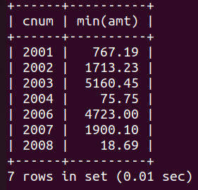

4. D1_nihar_84066>select cname from CUSTOMERS where cname like 'G%' order by cname asc limit 1;
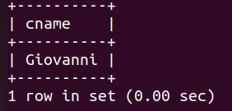

5. D1_nihar_84066>select distinct city, max(rating) from CUSTOMERS group by city;

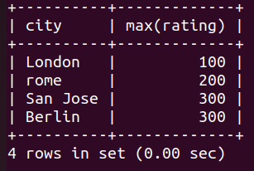

6. D1_nihar_84066>select distinct snum, count(distinct odate)"no of distinct orders" from ORDERS group by snum;
